PRESS RELEASE

Presentation of the 72nd edition of Flormart - The Green Italy, the leading exhibition of horticulture, green space and landscaping, scheduled from 20 to 22 September in Padua.

HORTICULTURE AND URBAN GREEN SPACE, BOOMING SECTORS

Speaking at the press conference was the Hon. Patrizio Giacomo La Pietra, Undersecretary of State for Agriculture, Food Sovereignty and Forestry.

PARMA, 6 JUNE 2023 - According to the latest ISTAT report, despite some significant challenges (including rising energy and raw materials costs, as well as the damage caused by climate change), horticulture remains a rapidly growing sector. In 2022, Italy saw an increase in the sector's turnover to around 3 billion euros, which accounts for 15% of the entire production in the European Union. In addition, the horticulture sector employs 200,000 people every day, with 24,000 companies and 30,000 hectares of cultivated land, while the export of Italian horticultural and floricultural products exceeds 900 million euros. This is what emerged from the press conference held today in Rome to present the 72nd edition of Flormart - The Green Italy, scheduled to take place from 20 to 22 September 2023 in Padua.

Horticulture, forestation and urban space: a thriving sector
As for the agricultural sector, with an added value of 38.4 billion euros in 2022, Italy is in second place in the EU-27, after France (43.5 billion) and ahead of Germany (30.9 billion) and Spain (28.5 billion). In terms of the value of agricultural production, Italy ranks third (72.4 billion euros, +18.2%), after France (which maintains its lead in the EU-27 with
96.6 billion euros, +17.2% compared to 2021) and Germany (74.4 billion euros, +25.7%). Numerous urgent measures have been implemented at an economic level, but there is a growing demand from various quarters for structural and long-term measures to facilitate the energy transition towards renewable resources for the entire green supply chain. The

future of horticulture, therefore, is truly green, renewable and responsible. Above all, the sector is one of the strengths of many National Recovery and Resilience Plan (PNRR) implementation projects.

"I believe that horticulture is a strength of Italian agriculture and that it has wide margins for growth," said Patrizio Giacomo La Pietra, Undersecretary of State for Agriculture, Food Sovereignty and Forestry. "Margins that we can also achieve through the support of prestigious events such as Flormart, which make it possible to promote the different facets of the sector. The Legislative Bill that we have presented together with Minister Lollobrigida is designed precisely to achieve this growth target through the creation of a national framework law that will serve as a benchmark for the sector. We want to set up a system for the entire sector, by creating a national coordination mechanism capable of identifying guidelines for the horticulture sector. The challenges that await us must be tackled collectively, by public institutions and private individuals, because only by acting in a coordinated manner will we be able to make our horticulture sector stronger and more competitive."

Great business opportunities for “Green Italy”
However, it is primarily the green living sector that knows no crisis and represents a driving trend for the green segment: today, the design and furnishing of urban spaces play the most important role in terms of well-being. Urban areas that strategically integrate green and liveable spaces are real oases of well-being and there is a growing awareness of the connection between greenery, beauty, and health. Outdoors and indoors merge, creating a single space to experience and inhabit. This trend, certainly very pronounced in big cities (which have a long-standing record of addressing major issue of optimal management of green spaces), is now increasingly gaining ground in the administrative and management culture of cities of different sizes. These virtuous policies strive to meet a very strong need in the community, one that is backed up by research in the field.
Many studies have demonstrated the close link between contact with nature and psychological and physical well-being. Recent research by the Barcelona Institute for Global Health (ISGlobal), in collaboration with Colorado State University and the World Health Organization (WHO), has shown a correlation between proximity of urban spaces to one's home with a lower incidence of early-onset diseases.
"Our experience in recent years,” commented Antonio Cellie, CEO of Fiere di Parma, “has accelerated a process that had already started and was quietly progressing: the rediscovery of how important it is to live in places that make us feel good. Italy has always been known as the country of bon vivre, and in the "Green Italy" that we will be presenting at the exhibition it will be more and more necessary (as well as felt at the level of the civic community) to update the strategic and cultural approach to this issue. The rethinking of urban spaces,

landscape design and the enhancement of green spaces as meeting points and places of well- being are key topics that today are demanding a central place on the public agenda.”

The press conference was an opportunity to present the main innovations of Flormart
- The Green Italy 2023.

Product sectors and exhibitors
Visitors to Flormart - The Green Italy have at their disposal a rather original compass for navigating through the different product sectors and activities on offer in the exhibition pavilions: the five primordial elements of nature.
The first is the earth, the cradle of roots and essential starting point of every story or project; it represents all horticulture professionals, the operators involved in the preparation of the host fields, and the specialists in cultivation techniques. The companies in this area will include Apice Piante, Cantatore Vincenzo Nursery Company, Giorgio Tesi Group, Graines Voltz, Romiti Nurseries, Spinelli Gerardo Nurseries, Sylvia Nurseries, Fratelli Dainese Nurseries, Guagno Nurseries, Nord Nurseries, and Onlymoso Nurseries.
Air, the current that drives change, brings together architecture and landscaping firms, construction companies and green designers, all indispensable interpreters of the new 'Green Italy' trends, capable of fuelling innovation and thus finding new models for conceiving and creating green spaces. This fascinating area includes companies with a very high technological and digital expertise, such as Harpo, Irriworks and NBL. Water, the source of life, takes the visitor to the world of irrigation and, more generally, to the means of production at the service of the green sector. Agraria Checchi Silvano, Agrivivai, Energy Green, Progetto20 are some of the most renowned companies in this field, ready to animate an area extremely rich in stimuli and encompassing important topics.
Fire, the energy that moves the sector, represents a space dedicated to green space maintenance machines and research in the field of crop care. This highly technical area is represented at the exhibition by leading companies such as Holmac, John Deere, Kobelco, Mean Green, Meccanica Morellato, Nutriplant, Peruzzo, Saviolife, Spider.
Finally, the fifth element of Flormart - The Green Italy, the true dynamic soul of the trade show, which looks resolutely to the future: in this space, the dynamism of start-ups, the innate ability of the media to capture new trends, and the added value of specific company- based training find their ideal dimension. A.I.B. All Insurance Broker, Associazione Italiana Professionisti del Verde (Italian Association of Green Professionals), Associazione Pubblici Giardini (Association of Public Gardens), Assoverde, and CONAF are just some of the participants that will bring know-how and valuable content to this area.

New stakeholders: from public administrations to international buyers,
Flormart – The Green Italy is a trade show that caters to operators in the horticulture

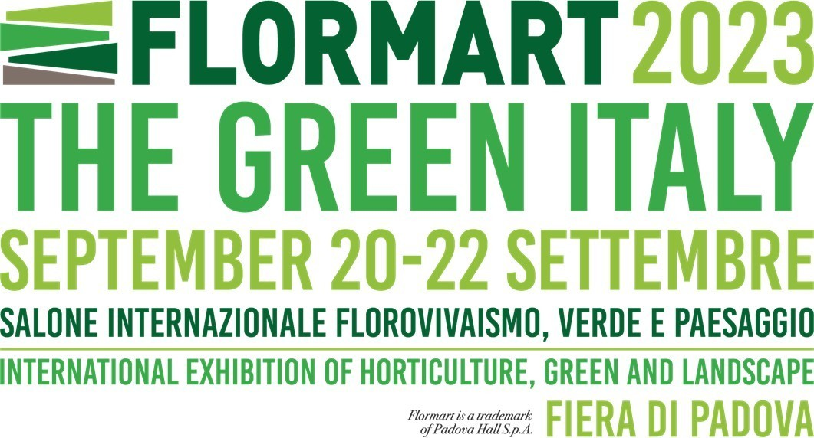
sector, ranging all the way from producers and growers to garden centres, covering the entire green sector supply chain in a dynamic and comprehensive way. For example, green designers, landscapers, and architects, as well as institutions, public administrations and urban planning authorities, all play an increasingly central role. In addition to these new visitors to Flormart - The Green Italy, the large retail sector and discount stores (provided that the distinction between the two still holds today) are also expected. Both distribution formats, after starting a few years ago with a corner dedicated to DIY, are now allocating more and more shelf space to horticulture, furnishings, and home gardening.
The stated goal of Flormart - The Green Italy is to create and enhance synergies between manufacturing companies and retailers arriving from Italy and abroad. At the heart of the mission of Fiere di Parma, the organizer of the exhibition for the second year running, is the promotion of Made in Italy products in international markets. Flormart - The Green Italy is not holding back from this ambitious goal and, to this end, is implementing two programs: Flormart Buyers Program and Flormart Experience, both developed in collaboration with the Italian Trade Agency (ICE) and with the support of major national and international industry associations. These two incoming initiatives offer a unique and comprehensive business experience to selected professionals. The aim is to raise their awareness about the importance of Italian horticulture as an authentic expression of the Made in Italy sector and, at the same time, to provide exhibiting companies with valuable commercial and promotional opportunities.
A broad variety of attendees have already confirmed their participation in the programs, including renowned landscape designers and studios - such as Desert Group from the United Arab Emirates and Studio Atelier Nous from Paris - and well as giants in the events and entertainment industry (Disneyland Paris, among others).
"Horticulture is an important sector in the Italian economy," said Roberto Luongo, General Manager of the Italian Trade Agency (ICE), "and it plays a significant role in our exports. ICE confirms its support for Italian companies in the industry and, in collaboration with Fiere di Parma and Fiera di Padova, supports the internationalization of Flormart - The Green Italy, a showcase for the excellence of the sector." 170 top buyers from all over the world make up the international delegation of the Italian Trade Agency (ICE) at the 2023 edition of the event, supported by the implementation of a promotional campaign in the focus countries.”

Trending topics of the future: the programme of conferences
Just over a decade ago, the trend of the moment was urban gardening; next, it was the turn of vertical farming. Today, the keyword is undoubtedly responsibility. It goes without saying that trends, which vary and evolve every year, not only dictate fashion but also influence behaviours and purchase, as they incorporate increasingly felt social needs that involve politics, local administrations, and active citizenship. What, then, are the upcoming trends?

The trending topics of the future will be the focus of numerous conferences to be held at Flormart - The Green Italy. Among the hot topics that will be addressed are the effects of climate transition on the urban landscape system; speakers will include nursery experts, green planners and designers, as well as urban green management authorities from Italy and abroad. The focus of another conference will be on European green city projects and outline an initial strategy for the development of green spaces in cities. Another macro topic will be the correlation between green spaces and quality of life, the role of the pharmaceutical industry in the horticulture context, health parks and healing green spaces. There will be in-depth discussions on the certification system as a mark of quality, and on the design, construction, and management of urban green spaces, parks, and gardens. Other topics of investigation will include regulations and innovation in the substrates sector and the prospects of the ornamental and forestry horticulture sector.

Flormart - The Green Italy: International showcase of horticulture since 1971
Flormart - The Green Italy will take place in Padua from 20 to 22 September, 2023.
Since 1971, Flormart - The Green Italy is the long-standing professional event dedicated to horticulture: a unique brand and tradition in Italy and in Europe. It is an international showcase and highly specialized professional event dedicated to the entire green supply chain.
Starting with the horticulture sector, Flormart - The Green Italy has grown over the years to incorporate the green sector in its broadest sense: from landscape design to environmental engineering, from green cities to urban furnishing, from digitization to the new green professions.
The exhibition showcases various product sectors: green space construction and maintenance; design and innovation; technologies, equipment and means of production; research, management and crop care; start-ups, media, services, and training.

Over the course of its 72 editions, Flormart - The Green Italy has been the platform for knowledge sharing among professionals in the sector and a meeting point for the various supply chain stakeholders. These include nurserymen, growers, designers, green construction and maintenance companies, retailers of plants and flowers, end-users and public bodies.

Fiere di Parma, organizer of successful international events, boasts 80 years of trade fair experience, always providing technologically advanced solutions that combine tradition, innovation, and sustainability. Its mission: to promote the excellence of Made in Italy products worldwide.

Info: Flormart - The Green Italy – https://flormart.it/

LinkedIn @Flormart - The Green Italy - Instagram @flormart.thegreenitaly
Facebook @FlormartPadova – YouTube @Flormart Padova

Press Office: Studio Eidos di Sabrina Talarico Tel. +39 049.8910709 www.studioeidos.it

